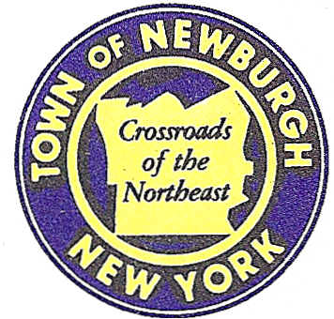

TOWN OF NEWBURGH
_______Crossroads of the Northeast __________________________
OLD TOWN HALL
308 GARDNERTOWN ROAD NEWBURGH, NEW YORK 12550

PLANNING BOARD
JOHN P. EWASUTYN, CHAIRMAN
TELEPHONE 845-564-7804
FAX 845-564-7802
E-MAIL: planningboard@townofnewburgh.org

PLANNING BOARD AGENDA

December 1st, 2016

*PLEASE NOTE: The Planning Board Meeting will start at 7:00 P.M. and all Applicants/Representatives
are to be present at that time. The Meeting will be held in the Meeting Room of Town Hall,
located at 1496 Route 300, Newburgh NY.*

1. Restaurant Depot (15-33) SIGNAGE PLAN
NYS Route 300
Section 95, Block 1, Lot 8
Zone: IB
Rep: Larry Marshall, P.E.
Mercurio- Norton-Tarolli & Marshall
45 Main Street
Pine Bush, NY 12566

2. Mavis/Mixed Use (15-03) AMENDED SITE PLAN
1413 Union Avenue
Section 60, Block 3, Lot 40.2
Zone: IB
Rep: Bohler Engineering
5 Computer Drive West, Suite 203
Albany, NY 12205

*WORK SESSION*
Project Readiness Discussion scheduled for 6:00 p.m. in the Meeting Room of
Town Hall on Thursday, December 1st, 2016.*

PLANNING BOARD BUSINESS
WORK SESSION

*WORK SESSION*
Project Readiness Discussion scheduled for 6:0 0 p.m. in the Meeting Room of
Town Hall on Thursday, December 1st, 2016.*

